Electronic Supporting Information

Synthesis, theoretical and photophysical studies of mono-alkynylated tetrathienylethene via Sonogashira reaction: A useful tool for enhancement of their aggregation induced emission properties.

Gioi V. Nguyen¹, Minh T. Do¹, Tuan Anh Ly¹, Huy T. Nguyen¹,
Giang Thi Phuong Ly¹, Quang T. Tran¹, Hien Nguyen², Tung T. Dang¹,*

¹ School of Chemistry and Life Science, Hanoi University of Science and Technology, 1 Dai Co Viet Road, Hanoi, VIETNAM
² Hanoi National University of Education (HNUE), 136 Xuan Thuy, Cau Giay, Hanoi, Vietnam
* Email: tung.dangthanh@hust.edu.vn and hiennguyendhsphn@gmail.com

SI-1 Materials and methods
General Remarks
All chemicals and solvents were obtained from commercial suppliers and employed without further purification unless specified otherwise. Dichloromethane, hexane, and ethyl acetate of reagent grade were purified by distillation before using. Air- and moisture-sensitive reactions were carried out under an argon atmosphere using standard techniques.
Reaction progress was monitored by thin-layer chromatography (TLC) on silica gel plates (Silica gel 60 F254, aluminium-backed or glass-supported), with visualization achieved under UV irradiation at 254 nm. Purification of products was performed by flash column chromatography on silica gel (Kieselgel 60, 230–400 mesh).
Nuclear magnetic resonance (NMR) spectra were recorded on a 500 MHz spectrometer, using tetramethylsilane (TMS) as an internal reference. Chemical shifts (δ) are reported in parts per million (ppm). For ¹H NMR spectra, residual solvent signals were used as reference (CDCl₃: δ 7.26 ppm), and for ¹³C NMR spectra, the solvent signal of CDCl₃ (δ 77.16 ppm) was showed.
Signal multiplicities are designed as follows: s (singlet), d (doublet), dd (doublet of doublets), ddd (doublet of doublet of doublets), t (triplet), td (triplet of doublets), q (quartet), and m (multiplet). Coupling constants (J) are reported in hertz (Hz), and integrations correspond to the number of protons.

SI-3 Synthetic procedures
Scheme S1 Preparation of mono-alkynyl-substituted tetrathienylethene 25a-e
Synthesis of Tetrathienylethene (22):
Tetrachloroethene 21 (600 mg, 3.6 mmol, 1 equiv.) and 2-(tributylstannyl)thiophene (6.72 g, 18 mmol, 5 equiv.) were put in an oven-dried pressure tube equipped with a magnetic stir bar under an argon atmosphere. The reaction mixture was degassed by argon for 15 minutes before catalyst addition. Pd(OAc)₂ (40.2 mg, 0.18 mmol, 5 mol%) and XPhos (171.2 mg, 0.36 mmol, 10 mol%) were then added, and the system was then flushed with argon before sealing. The sealed tube was heated and stirred at 80 °C for 48 h. After cooling to room temperature, brine was added, and the mixture was extracted with dichloromethane (3 times). The combined organic layers were dried over anhydrous Na₂SO₄, filtered, and concentrated under reduced pressure. The crude product was purified by flash column chromatography on silica gel (hexane/ethyl acetate) to afford compound 22 (770 mg, 60%) as an orange solid. Rf = 0.4 (SiO₂, hexane/ethyl acetate = 20:1). The spectroscopic data were consistent with those reported in the literature[1].
Synthesis of mono(1- bromo)- tetrathienylethene (24):
Tetrathienylethene 22 (500 mg, 1.4 mmol, 1 eq) was dissolved in dry DMF (5 mL) and cooled to 0 °C using an external ice bath. A solution of N-bromosuccinimide (275 mg, 2.15 mmol, 1,1 eq) in DMF (5 mL) was added dropwise over 20 minutes with continuous stirring. The reaction mixture was maintained at 0 °C for 5 h and then allowed to warm gradually to room temperature and stirred for another 19 h. The reaction was quenched by the adding saturated aqueous sodium thiosulfate to neutralize residual bromine. The mixture was then extracted with dichloromethane (3 times). The combined organic layers were dried over anhydrous Na₂SO₄, filtered, and concentrated under reduced pressure. The crude product was purified by flash column chromatography on silica gel (hexane/ethyl acetate) to afford compound 24 (596 mg, 98%) as an orange solid. Rf = 0.5 (SiO₂, hexane/ethyl acetate = 20:1). The spectroscopic data were consistent with those reported in the literature [2].
General procedure for synthesis of mono-alkynyl-subtituted etrathienylethene (25a-e):
Mono(1-bromo)-tetrathienylethene 24 (50 mg, 0.11 mmol, 1eq), the corresponding aryl acetylene (0.165 mmol, 1.5 eq), Pd(PPh₃)₄ (6.3 mg, 0.0055 mmol, 5%), and CuI (2.5 mg, 0.0132 mmol, 12%) were put in an oven-dried pressure tube equipped with a magnetic stir bar under an argon atmosphere. Triethylamine (1 mL) and THF (4 mL) were added, and the reaction mixture was degassed by argon before sealing the tube. The reaction was heated and stirred at 65 °C for 5 h. After cooling to room temperature, brine was added, and the mixture was extracted with dichloromethane (3 times). The combined organic layers were dried over anhydrous Na₂SO₄, filtered, and concentrated under reduced pressure. The crude product was purified by flash column chromatography on silica gel (hexane/ethyl acetate) to afford the desired products 25a–e.
Scheme S2. Synthesis of alkynyl-subtituted tetrathienylethene 25a-e

SI-4 NMR spectra of synthesized compounds
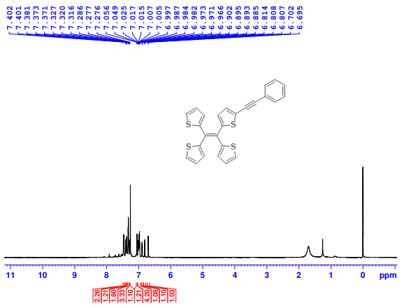
Figure S1 1H NMR spectrum (500 MHz, CDCl3) of compound 25a
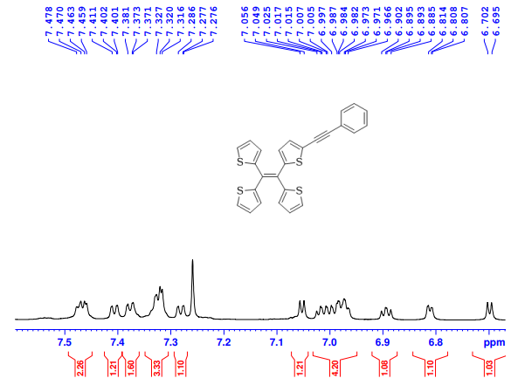
Figure S2 1H NMR expanded spectrum (500 MHz, CDCl3) of compound 25a
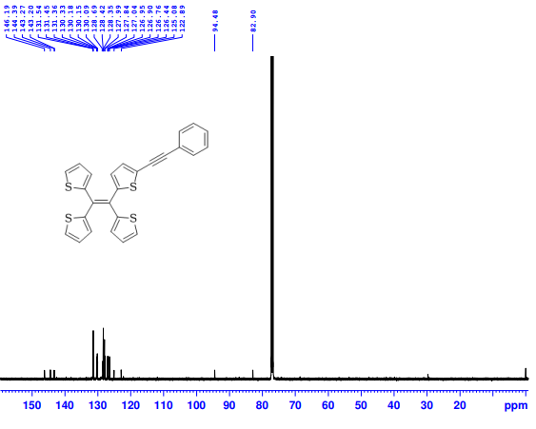
Figure S3 ¹³C NMR spectrum (125 MHz, CDCl₃) of compound 25a
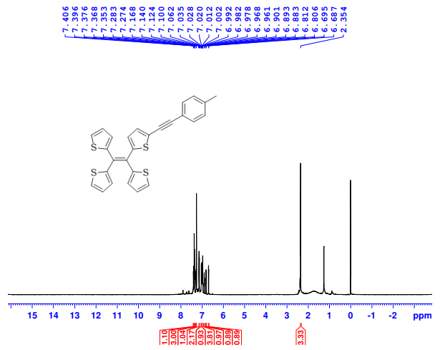
Figure S4 ¹H NMR spectrum (500 MHz, CDCl₃) of compound 25b
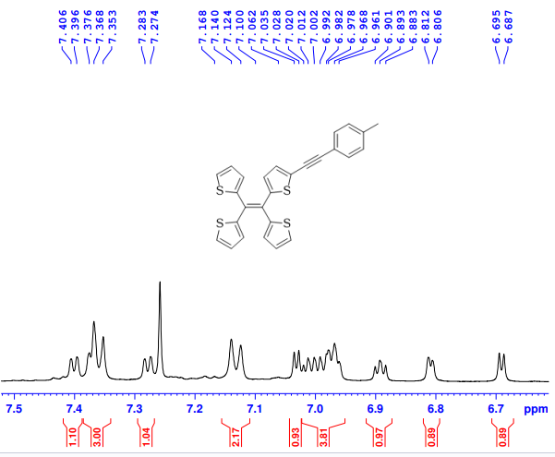
Figure S5 ¹H NMR expanded spectrum (500 MHz, CDCl₃) of compound 25b
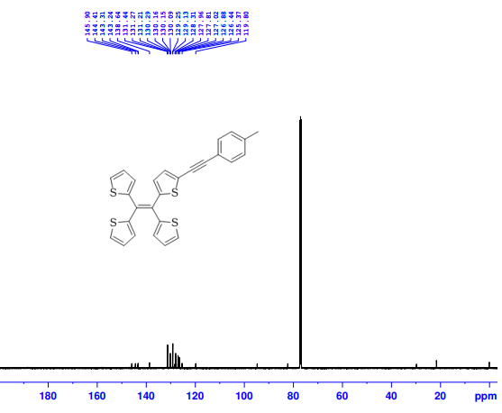
Figure S6 ¹³C NMR spectrum (125 MHz, CDCl₃) of compound 25b
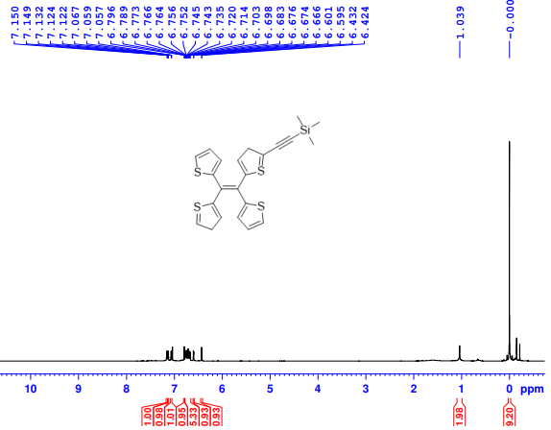
Figure S7 ¹H NMR spectrum (500 MHz, CDCl₃) of compound 25c
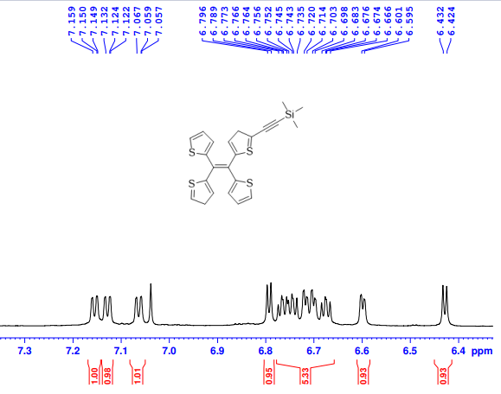
Figure S8 ¹H NMR expanded spectrum (500 MHz, CDCl₃) of compound 25c
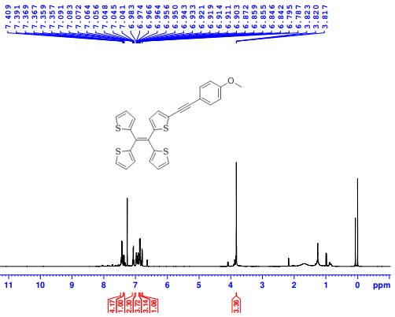
Figure S9 ¹H NMR spectrum (500 MHz, CDCl₃) of compound 25d
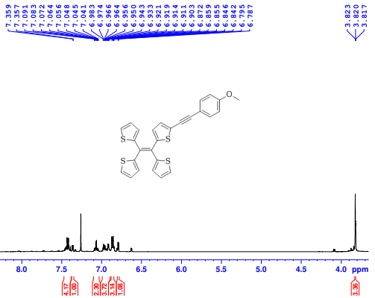
Figure S10 ¹H NMR expanded spectrum (500 MHz, CDCl₃) of compound 25d
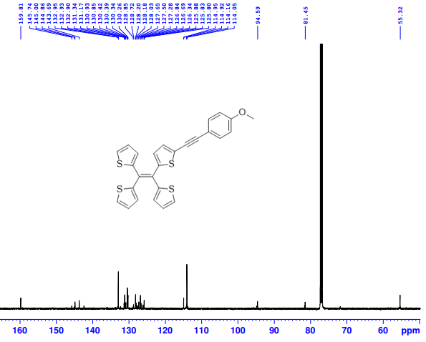
Figure S11 ¹³C NMR spectrum (125 MHz, CDCl₃) of compound 25d

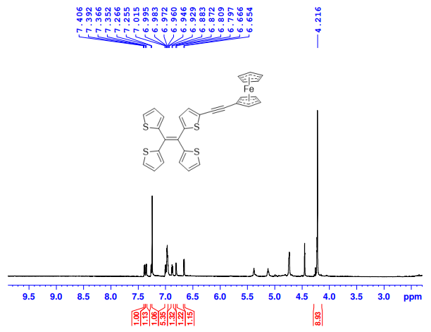
Figure S12 ¹H NMR spectrum (500 MHz, CDCl₃) of compound 25e
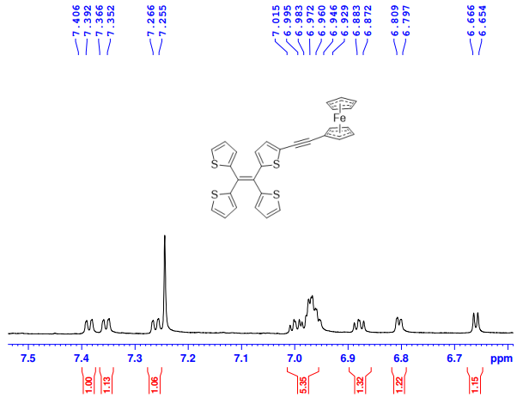
Figure S13 ¹H NMR expanded spectrum (500 MHz, CDCl₃) of compound 25e

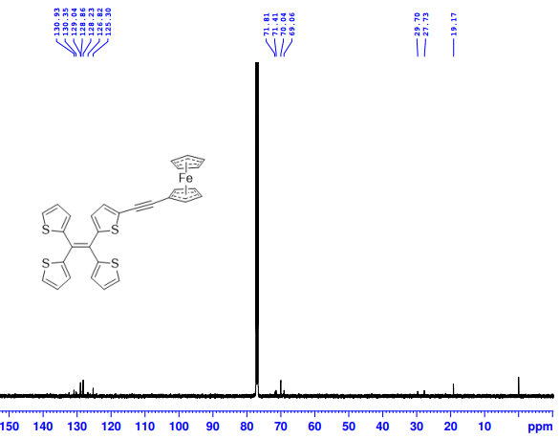
Figure S14 ¹³C NMR spectrum (125 MHz, CDCl₃) of compound 25e

